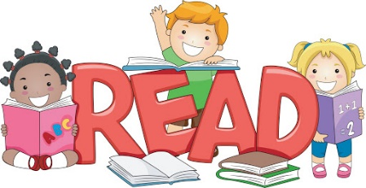
Perryfields Primary PRU
Lockdown Reading
Learn the lyrics to your favourite song. | Read a comic then draw a comic strip of your own. | Find and Complete a word search  ( there are some uploaded onto our school website for you to use)
Read inside a den you have made. | Read to someone else. | Find 3 new words in your book and find out what they mean.
Follow instructions on how to make something. Eg a recipe, make Lego, K’nex or Meccano | Write a new ending for one of your favourite books. | Create some Top Trump cards using the Heroes and Villains from the story.
Are you ready to lose yourself in a book!
How many different ways can you enjoy reading during Lockdown? Here are some interesting ways to have fun with reading. When you have done one, colour it in. Can you complete a whole row or column? Take some photos of you enjoying the activities and e-mail them to your teacher or office@perryfields.worcs.sch.uk

