Lockdown Home learning grid 4

English  This week we will be exploring how to write detailed, imaginative descriptions of settings within stories. To remind yourself of setting and context go to: https://www.bbc.co.uk/bitesize/articles/z4brcqt  Now look at the setting picture and answer the questions about the setting. | English  Compare and contrast settings lesson:  Look at the following descriptions and answer the questions about different settings:  Contrasting settings with tasks  The air smelt salty and fresh. Grains of golden sand slipped between fingers and toes, whilst the calm, lapping waves whispered in the gentle breeze. Soft fluffy clouds twinkled in the sunlight as a yellow wooden boat bobbed serenely on the silky sea. Pink, sticky ice-cream dripped on clean white towels and parasols framed the coastline.  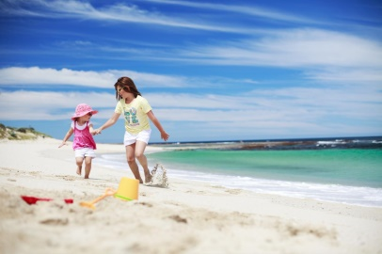  Raucous buzzing screeched in all ears, as currents of electric ripped through the darkest blue skies. Pounding waves leaped and darted between and over bashed rocks. Cries of pain erupted from the nests of seagulls and violent shouts of fury from the mouth of the ocean. Whilst beaches parted in fear and threatening waves rose from the depths, boats were thrown and tossed in the night sky, with no hope of rescue.  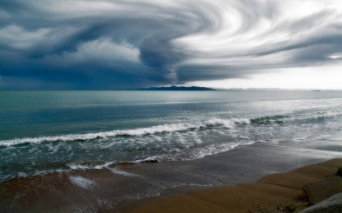  - Highlight all the powerful verbs in each paragraph. Which is the most effective and why?  - Highlight all of the interesting adjectives in each paragraph. Which is your favourite? Can you think of synonyms for the word?  - Underline the conjunctions used in the two paragraphs.  - Underline prepositions used in the two paragraphs.  - Which paragraph do you think is the most effective and why? | English  Writing complex sentences with prepositions.  Use the picture to brainstorm ideas for settings vocabulary.  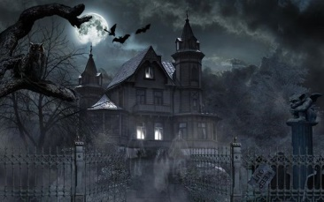  Remember to think about senses. What can be seen, heard, smelt, felt (this can be feelings as well as touch): She felt sharp, spiky branches scratching and tearing her hands.  Use the planning sheet to help organise your ideas. (double click to enlarge).  Now write five sentences using your ideas, trying to extend them using conjunctions and/or prepositions. To remind yourself go to: https://www.bbc.co.uk/bitesize/articles/zbkwqp3  Example: Inside, the air hung with damp and decay, making it extremely difficult to breathe easily.  As the thick fog descended, the children stopped running and found themselves in front of a huge, deserted house.  Try to include: As, Before, Although, When, If, Since, Whilst. |  | English  Today you are going to write your own setting description based on your ideas from yesterday. It should be an extended piece of writing, drawing your reader into the atmosphere. Try to include short sentences for tension / suspense. You could include onomatopoeia for effect. Also include a mix of compound (using conjunctions) and complex (using prepositions and fronted adverbials) sentences to extend your ideas and `explain it more` for your reader.  When you have completed your description, use the uplevelling sheet to purple polish your work. |  | English  Zap Zone  Free choice writing! Today you have the option to write about whatever you chose. This could be:  - A story  - A character description (real or made up)  - A scene description  - A diary entry  - A letter  - A play script  - A poem  - A Non-Chronological Report  - A newspaper article  Or anything else you would like to write about! When you are writing, I would like you to think back to the punctuation work that you did last week, and ensure that your punctuation is perfect! Don’t forget to email me to show me what you have done!
Topic  So we started out with looking at the world, and then its continents. Now you are ready to do your own mini project on a country of your choice!  You can choose any one country that you would like to look at in detail for the work over the coming weeks. You can be as creative as you like when doing each task: it could be writing, cooking a dish, art work - you can decide how you wish to tackle it. Here are some useful websites to help you with finding information.  https://www.natgeokids.com/uk/category/discover/geography/  https://www.ducksters.com/geography/  https://www.kids-world-travel-guide.com/  https://www.3dgeography.co.uk/  For each task, we will give you the area we would like you to look at and some suggestions to help you if you are unsure.  Monday and Tuesday  Choose the country you would like to look at in detail for your mini project. You have Monday and Tuesday for this task so you have time to make it amazing!  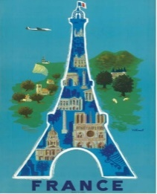  Create a title page for your country. Here are some ideas but it is up to you! For example, you could choose to draw it, collage it or make it on the computer! Make sure you include lots of things that represent the country of your choice! |  | Topic  Wednesday  Carry out some research about the flag of your country. Write a few sentences about it and then draw or make your flag. How you present it is up to you! | Science  Thursday  Watch the video on the life cycle of a flowering plant: https://www.bbc.co.uk/bitesize/clips/zgqyrdm  Go for a walk or look at flowers and plants in your garden. What stage of the plant’s life cycle are they at? How do you know? Take some photos. What do you think they would look like at a different time of year? You could draw some pictures of what you think the different stages of that plant’s life cycle might look like. |  | Topic  Friday  Have a go at an online escape room, either on your own or with your family at the following website:  https://www.escapefromhome.co.uk/?fbclid=IwAR2YjuCFSIckmlNJSSQrgEMWrKk_6ZJLPDrUkXxUdJ1CY25KiVjZNmjp1A4  Whilst some you need to pay for, the free ones are:  - The Egyptian Escape (you will need to remember the work that you did on the Egyptians in Y4!)  - A Pirate’s Problem  - Global Gateway (which is a bit trickier!)  Have fun!

The Daily 10  Complete the ‘daily 10’ challenge on the Top Marks website. There are lots of different options. If you finish it quickly, maybe you can try a different challenge or keep practising just one if it was hard.  https://www.topmarks.co.uk/maths-games/daily10  Level 1 = Challenge 1  Level 2 = Challenge 2  Remember to focus on 2s, 5s, 10s | Shape Day One  Try some Shape activities on bbc bitezize -  Challenge One:  -2D and 3D Shape sorting  -Name 2D Shapes (Pairs)  Challenge Two:  -3D Shape Pairs  -Label shapes (2D & 3D)  Challenge Three:  -Write about 2D Shapes. Choose 6 and create a poster.  -Write about 3D Shapes. Choose 6 and create a poster  Remember to include all the properties!  Just for fun:  Lines of symmetry. What do you notice about the regular 2D Shapes and the number of lines of symmetry they have? | Shape Day Two  Think about your learning from Day One. Can you find any of these shapes (2D and 3D) in your house? Do any of the shapes have lines of symmetry?  You can present your findings any way you like. You could take some pictures or you could draw the items.  Make sure you write the names of the shapes you have found and any properties.  2D Shapes:  How many sides/corners?  3D Shapes:  How many faces/edges/vertices? | Shape Day Three  Using all your shape knowledge, can you create a picture of the seaside using 2D and 3D Shapes?  Think about all the different shapes you might see at the seaside. How many different shapes can you put on your picture? You can label the shapes if you like!  Remember if the shape has straight lines you should use a ruler (if you have one!)

