CHILD PROFILE
NAME………………………..….………. ……..….……….………………………………………….
ACADEMIC
SOCIAL INTERACTION

ACEs / TRAUMA


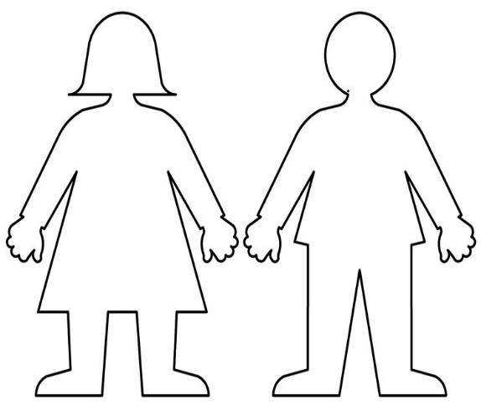
WHAT TRIGGERS WOULD CAUSE A NEGATIVE RESPONSE
STRENGTHS
FAMILY / HOME ENVIRONMENT
HOBBIES / INTERESTS

WHAT TRIGGERS WOULD CAUSE A POSITIVE RESPONSE
DIAGNOSIS

